**ІМЕНІ ТАРАСА ШЕВЧЕНКА**

**ФАКУЛЬТЕТ ІНФОРМАЦІЙНИХ ТЕХНОЛОГІЙ Кафедра прикладних інформаційних систем**

ЗВІТ

Про виконання лабораторної роботи №7

з дисципліни: «Технології розроблення програмних систем»

Студент групи ПП-42

Мельник Валентин

Київ – 2022

**Тема**: Обʼєктно-орієнтовані метрики коду

**Код програми:**

Для перевірки обрав бібліотекe numpy

import inspect  
import sys  
  
import tabulate  
import numpy  
  
class ClassStats:  
 def __init__(self):  
 self.inheritance_depth = 0  
 self.child_count = 0  
 self.inherited_methods_count = 0  
 self.overridden_methods_count = 0  
 self.new_methods_count = 0  
 self.visible_methods_count = 0  
 self.private_methods_count = 0  
  
class MetricCounter:  
 def __init__(self):  
 self.__cached_inheritance_depths: dict[type, int] = {}  
 self.classes_stats: dict[type, ClassStats] = {}  
  
 def count_class(self, clazz: type) -> ClassStats:  
 class_metrics = ClassStats()  
 class_metrics.child_count = len(clazz.__subclasses__())  
 class_metrics.inheritance_depth = self.count_class_inheritance_depth(clazz)  
 self.count_props(clazz, class_metrics)  
 self.classes_stats[clazz] = class_metrics  
 return class_metrics  
  
 def count_class_inheritance_depth(self, clazz: type) -> int:  
 if clazz in self.__cached_inheritance_depths:  
 return self.__cached_inheritance_depths[clazz]  
 if clazz.__base__ == object:  
 inheritance_depth = 0  
 else:  
 inheritance_depth = self.count_class_inheritance_depth(clazz.__base__) + 1  
 self.__cached_inheritance_depths[clazz] = inheritance_depth  
 return inheritance_depth  
  
 def count_props(self, clazz: type, out_stats: ClassStats):  
 new_methods = 0  
 inherited_methods = 0  
 overridden_methods = 0  
 visible_methods = 0  
 private_methods = 0  
 for name, obj in inspect.getmembers(clazz):  
 if inspect.isroutine(obj):  
 if name not in clazz.__dict__:  
 inherited_methods += 1  
 elif any(name in super_class.__dict__ for super_class in clazz.mro()[1:]):  
 overridden_methods += 1  
 else:  
 new_methods += 1  
 if name.startswith(f'_{clazz.__name__}') and not name.endswith("__"):  
 private_methods += 1  
 else:  
 visible_methods += 1  
 out_stats.new_methods_count = new_methods  
 out_stats.overridden_methods_count = overridden_methods  
 out_stats.inherited_methods_count = inherited_methods  
 out_stats.visible_methods_count = visible_methods  
 out_stats.private_methods_count = private_methods  
  
 def get_polymorphism_factor(self) -> float:  
 overriden_methods = 0  
 denom = 0  
 for clazz, stats in self.classes_stats.items():  
 overriden_methods += stats.overridden_methods_count  
 denom += stats.new_methods_count * stats.child_count  
 if overriden_methods == 0 or denom == 0:  
 return 0.0  
 return overriden_methods / denom  
  
 def get_method_inheritance_factor(self) -> float:  
 inherited_methods = 0  
 all_methods = 0  
 for clazz, stats in self.classes_stats.items():  
 inherited_methods += stats.overridden_methods_count  
 all_methods += stats.new_methods_count + stats.inherited_methods_count + stats.overridden_methods_count  
 if inherited_methods == 0 or all_methods == 0:  
 return 0.0  
 return inherited_methods / all_methods  
  
 def get_closed_methods_factor(self) -> float:  
 private_methods = 0  
 all_methods = 0  
 for clazz, stats in self.classes_stats.items():  
 private_methods += stats.private_methods_count  
 all_methods += stats.visible_methods_count + stats.private_methods_count  
 if private_methods == 0 or all_methods == 0:  
 return 0.0  
 return private_methods / all_methods  
  
  
def class_stats_to_row(clazz: type, stats: ClassStats):  
 return [clazz.__name__, stats.inheritance_depth, stats.child_count]  
  
  
if __name__ == '__main__':  
 counter = MetricCounter()  
 for name, obj in inspect.getmembers(sys.modules['numpy']):  
 if inspect.isclass(obj):  
 counter.count_class(obj)  
 table_headers = ["Class Name", "Inheritance Depth", "Children Count"]  
 print(tabulate.tabulate([class_stats_to_row(clazz, stats) for clazz, stats in counter.classes_stats.items()],  
 headers=table_headers))  
  
 lib_factors = {"Closed Methods Factor": [counter.get_closed_methods_factor()],  
 "Method Inheritance Factor": [counter.get_method_inheritance_factor()],  
 "Polymorphism Factor": [counter.get_polymorphism_factor()]}  
 lib_factors_headers = ["Closed Methods Factor", "Method Inheritance Factor", "Polymorphism Factor"]  
 print(tabulate.tabulate(lib_factors, headers="keys"))

**Результат роботи програми:**

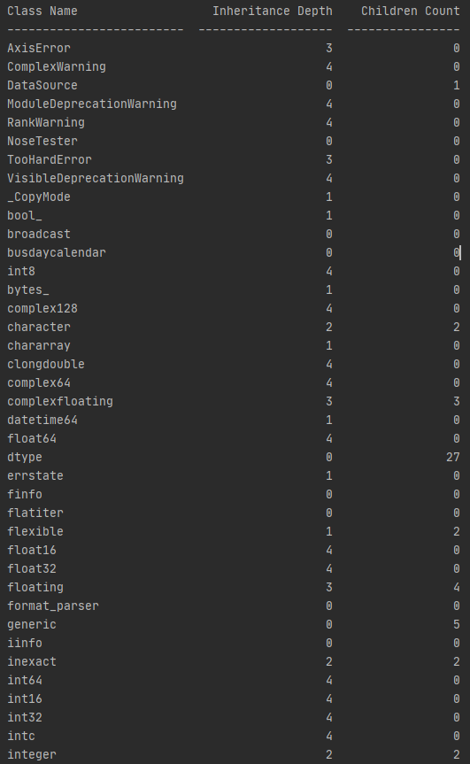

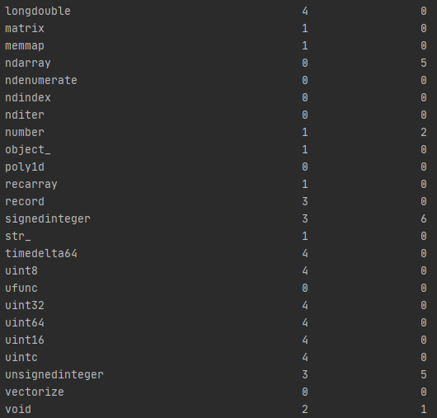

Також виводжу метрики коду

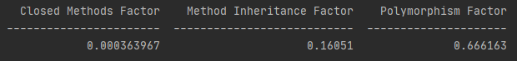

**Висновок**: в межах цієї лабораторної роботи я навчився обраховувати обʼєктно-орієнтовані метрики коду програм написаних на мові Python